Submitting Course Outlines for C-ID Designation

A Guide for Articulation Officers

Questions? Email: c-idsupport@asccc.org

Updated 3/19/2015 – Revisions (see pg. 33)

Introduction

This guide has been created to assist California Community College (CCC) Articulation Officers (AOs) with the submission of course outlines of record (COR) for Course Identification Numbering System (C-ID) designation. It is an instructional resource for the procedures associated with the submission of CORs for review against C-ID course descriptors. The instructions contained in this guide are based on C-ID policies. Like articulation itself, this guide will be an ever-changing resource that will be modified and updated as technology and C-ID policies evolve.
Table of Contents

Accessing the C-ID Website - Username and Password 4
Course Submission Page – Password Changes 5
Course Outline of Record Dates and Timelines for Review 5
Important - Prior to Submission of Courses 7
Areas of Review 8
Course Submission Page - Overview 10
First Step in the Course Submission Process 11
Entering Course Information and Attaching Course Outline 12
Attaching Course Outlines – Online Location/Upload Options 13
Textbook Changes 14
Adding Additional Courses 14
Entering Course Information and Attaching Course Outlines 15
Submitting a Course Where Articulation Already Exists 16
Multiple Course Alert 17
Final Step 18
Viewing Courses 19
Obtaining a Complete List of All Submitted Courses 20
Potential Course Status 21
Locating and Viewing Review Determinations 23
Resubmitting Courses - Step One 24
Resubmitting Courses - Step Two 25
Textbook Only Resubmissions 26
Textbook Information Required 27
Appealing a Determination 28
Editing Course Designation, Number, Title and/or Units 29
C-ID Approved Courses 30
CSU Articulation and C-ID Descriptors 30
Approved Descriptor List 31
Tips, C-ID Technology Updates and Contact Information 32
Recent Guide Revisions 33

Accessing the C-ID Website – Username and Password

- The first step in submitting courses to C-ID is to obtain your college’s username and password if you do not have this information already.
  - Email c-idsupport@asccc.orgor call (916) 445-4753 for your username and password.
- Articulation Officers should submit courses using their college name as their username. This procedure allows for a history of courses submitted by a particular college to be retained regardless of a change in Articulation Officer.
- With your username and password available, go to www.c-id.net.
- Click on the “Course Review” tab on the homepage.
- Login with your username and password (see screenshot of http://www.c- id.net/coursereview.html below).

Click on “Course Review”
tab from main C-ID website
Enter your username (college name) and password here

Course Submission Page – Password Changes
I. Once successfully logged in, you will see the submission page for your college. You may change your password here. Simply click on “Edit your profile”.
To change your password, click here

Course Outline of Record Dates and Timelines for Review
- Before submitting a course, you will need to enter the effective date of your Course Outline of Record (COR) on the course submission page (up to a year in advance), as well as the date your COR was approved at your institution. Please note that if you indicate a future effective date, an approved course will be visible on your course list but will not be available on the public “Courses” tab of the C-ID website until the effective date is reached.
  - Effective Date: The date your college began using the COR (i.e., when faculty began teaching that version of the COR).
  - Approval Date: The date the Curriculum Committee or Board approved your COR, depending upon your local policy.
- Course outlines over five years old will not be accepted. If you have an outline, which is more than five years old and submitted before the system required entry of an
approval date, the course will be deemed “not approved” by the reviewer. You will need to initiate the process once again with a valid course outline.
- TCSU Identified Courses
  - C-ID is no longer accepting the submission of TCSU approved course numbers for automatic C-ID approval.
  - TCSU courses already in the system from 2008 will be expiring on October 30, 2013. TCSU courses from 2009 and 2010 will expire on October 30, 2014.
- All course descriptors and TMCs are reviewed on a five-year cycle.
  - Please keep in mind the review cycle dates when you submit course outlines. The downloadable approved descriptor list (http://c-id.net/view_final.html) includes descriptor review dates.
- CORs must be resubmitted if:
  - The descriptor was modified by the Faculty Discipline Review Group (FDRG) substantially enough to warrant resubmission and it was communicated that resubmission is necessary or
  - The COR was revised such that it warrants resubmission (as a result of a substantial local curricular change).
    - A substantial change is defined as changes to any of the following: course content; course objectives/SLOs; prerequisites(s); corequisite(s); a unit change to less than the descriptor unit minimum.
- Other
  - Textbooks: It is expected that at least one of the textbooks on the course outline of record have a publication date within seven (7) years of the course outline approval date. There may be cases in which:
    - A more recent text is expected (e.g. a technology course) or
    - The publication date is less relevant (e.g. classic primary sources in literature, philosophy or history).
    - It is helpful to include a reference to the use of such exceptional materials with the C-ID course submission. (Tip: Discipline faculty should provide their college Articulation Officer with a brief statement regarding the use of materials that do not conform to the seven-year rule prior to submission of the course for C-ID approval)
    - The C-ID Advisory Committee determined that from Nov 1, 2012 forward, at least one (1) of the textbooks in the Course Outline must be from the last seven (7) years. If an FDRG determines that one or more textbooks need to be more recent, they will include that requirement on the descriptor (for descriptors developed or reviewed after Nov 1, 2012)
    - Regarding course outlines currently being reviewed for C-ID approval, or any that were denied or given conditional approval because of a textbook date, this new rule applies: at least one textbook needs to be from the last 7 years.

Important – Prior to Submission of Courses
- Check Course Appropriateness
  - C-ID requires that a Course Outline of Record meet all requirements of the descriptor (100%). (While additional components may be appropriate and expected, it must be apparent how the components of the descriptor will be addressed with the required breadth and depth.)
  - Course outlines submitted should address all areas of the descriptor.
  - A course outline may contain more than is required by a descriptor, but not less.
  - Consider submission intent (e.g. regular/ honor courses are two completely separate submissions; sequences require more than one COR be submitted in a single submission; submission may require more than one COR in a single submission to meet descriptor requirements as in quarter unit schools).
- Courses submitted inappropriately against a descriptor will not be reviewed
  - Lecture course for lab descriptor or vice versa
  - Inappropriate discipline.
  - Obviously incorrect descriptor (early history period course submitted against late history period descriptor.)
- Remember - When your college submits a course for C-ID designation, you are agreeing to accept that C-ID course from another college in lieu of your native course (intrasegmental articulation).

Areas of Review

- Prerequisites and Corequisites
  - The outline must have the same prerequisite or corequisite as is listed on the descriptor. Course outlines may contain a prerequisite or corequisite where there is none required by the descriptor. Prerequisites or corequisites in addition to or at a higher level than those required by a descriptor are also permitted. Descriptor advisories are strong recommendations only.

- Course Content
  - The COR does not have to include the exact same number of content areas listed in the descriptor, or the exact language. However, holistically, the COR must address the content required by the descriptor. An element that is contained in one part of the descriptor may be inferred from another component of the COR. There is no expectation that any element of the COR will be consistent with the descriptor in a word-for-word manner.

- Course Objectives/Student Learning Outcomes (SLOs)
  - The COR does not have to include the exact same number of objectives listed in the descriptor, or the exact language. However, holistically, the COR must address the requirements of the descriptor objectives. Although all C-ID descriptors are written using objectives, CORs may contain objectives, SLOs, or a combination of both. For the purposes of review, the SLOs will only be utilized as a benefit and not as an area for improvement or required addition. For example, if a COR from a college contains both objectives and SLOs, and does not have an objective from the descriptor in the objective area of the COR, but, the topic or theme is covered in the SLOs, then that topic/theme has been met as part of the holistic review. If, however, for that same COR, the topic or theme is in the COR objective area (or another area in such a way as it can be determined this requirement is met) but not covered on the SLOs, there will not be a request that it be added to the SLOs since the descriptor requirement was met elsewhere and C-ID descriptors do not contain SLO requirements.
- Course Units
  - The descriptor units are the minimum units required. The course outline may contain more units but not fewer units then as indicated on the descriptor.

- Methods of Evaluation
  - The methods of evaluation listed on a descriptor are examples unless otherwise indicated. Course outlines must indicate methods of evaluation that validate the course content. However, there may be methods of evaluation listed on the descriptor that are inherently necessary for the content of a particular course (e.g., essays for an English course).

- Textbooks
  - Textbooks listed on a descriptor are examples unless otherwise indicated. Course outlines submitted to C-ID must include material in this area as appropriate for the discipline and course.
  - In keeping with established articulation policies, the expectation is that at least one of the textbooks will have a publication date within seven (7) years of the course outline approval date. There may be cases in which a more recent text is expected (e.g. a technology course), the publication date is less relevant (e.g. classic primary sources in literature, philosophy or history) or an exception exists relevant to the particulars of the discipline in question.

Course Submission Page - Overview
Click here to view only courses with a conditional or not approved status
Click here to view courses you previously submitted
Click here to submit a course
- From this page, you can submit courses or view previously submitted courses.
  - To submit a course, begin by clicking on “Submit Courses.”
  - To see a list of all of your courses in the C-ID system for your college, click on
“View Submitted Courses.”
  - To see your college courses which were deemed conditionally approved or not approved, click on “View Conditional or Not Approved Courses.”

First Step in the Course Submission Process – Select a Discipline & Descriptor
- Click on “Submit Courses” from the welcome page. Select a discipline, click on “Show.” You will then be able to select the appropriate descriptor against which you are submitting a course from the drop down menu. You may need to get the approval of your discipline faculty to articulate with the approved C-ID descriptors. When your college submits a course for C-ID designation, you are agreeing to accept that C-ID course from another college in lieu of your native course (intrasegmental articulation).
- Tip: You can download an Excel spreadsheet of all approved C-ID descriptors from the Final Descriptors page (http://c-id.net/view_final.html).

Select a discipline
Click “show”
Select a descriptor
Click “go”

Entering Course Information and Attaching Your Course Outline
- Once you select a descriptor, the course submission page will appear.
- Your name, phone number, & email address will automatically populate.
- Begin entering the information about your course outline.
  - Please note that the Institution Course Designation and Number are entered into two different box fields. This area will soon be updated to provide drop down and auto-fill areas to assist in the submission process. The C-ID system validates course submissions against the ASSIST database. Monthly updates are provided by ASSIST. If you receive a message indicating that your course is not found, and it was recently submitted to ASSIST, it may not be included in the most recent update. You will have to wait until the next update for submission to C-ID.
- Indicate any changes to your textbooks not reflected on the course outline.

Attaching Course Outlines – Online Location/Upload Options
- On the submission page – you will see two options for associating your course outline: Other online accessible location (URL), and uploaded (PDF or Word document).
- We provided both options so you may select the one that is the most efficient for you.
- It is important that these options are used correctly or the review of your course could be significantly delayed.
Other Online Accessible Location
- This option allows you to enter a website link which takes viewers directly to your course outline.
- Once you select the “Other online accessible location”, a box will appear for you to enter the URL address. It is recommended that you copy and paste the address directly from the source and test it after you complete the submission to ensure it is working correctly. The link must go to a publicly accessible site - not password protected.

Select this option to enter a URL address
Uploaded
- You can directly upload a PDF or Word version of your course outline to the website.
- Once you click on “Uploaded”, a “Document File Upload” message will appear. You will then click on the “Choose File” button to select your document from its stored location. Do not use zip files or alternative file formats.

Select this option to upload a PDF or Word document.

Textbook Changes (Not Reflected on the Course Outline)
- You have the ability on first submission to indicate that newer textbooks are being used than are reflected on the submitted course outline. This information is displayed for the reviewers when they evaluate the appropriateness and age of your textbooks.
- If only one COR is needed to fulfill the requirements of the descriptor, simply click on submit and your course will enter the review process.

Enter textbook information not included on the outline (include title, author & year for each textbook currently being used that is not listed on the outline)

Adding Additional Courses
- Check the box indicating you need to add additional courses and then click “Submit”. This will take you to a page where you can enter your additional courses as part of the same submission process. You may need to include additional courses in order to meet the content and/or unit requirements of the descriptor. For example:
  - Sequence courses require the submission of more than one COR to meet the requirements of the descriptor.
  - Quarter schools may need to submit more than one COR to meet the requirements of the semester based descriptor.
Check this box if you need to include additional courses.

Entering Course Information and Attaching Your Course Outline
Your Previous Course Entry Will Appear Here
- The previous submission you entered for this descriptor will appear at the top of the screen and you can now enter additional courses, following the same steps. On your last entry, simply click “Submit” without checking the “Add another course” option. The courses entered in this single session will link together in the C-ID system.

Reviewers evaluate CORs submitted together against a single descriptor with the understanding that both courses must be taken in order to achieve the C-ID designation.
- As with a single course submission, once you click on “Submit”, the course(s) is then forwarded to the appropriate discipline primary reviewer, who assigns the course to regular faculty reviewers. The goal is to have reviews completed within 4 weeks. You will receive an email when a decision is made regarding your course.
- You can also check the status of your courses when you log into the C-ID website.
  - Please note that review time can be influenced by the availability of CCC and CSU reviewers.

Submitting Course Where An Articulation Already Exists
- Click on “Submit Courses” (first screen shot below)
- Select a discipline, click on “Show.” You can then select the appropriate descriptor against which you are submitting a course from the drop down menu (second screen shot below).
- Once you select a descriptor for which you already have an existing articulation, you will see a multiple course alert screen (See next section for information on multiple course alerts.)

Select a discipline
Click “show”
Select a descriptor
Click “go”

Submitting A Course Where An Articulation Already Exists - Multiple Course Alert
- Multiple course alerts appear when you submit a course where an articulation already exists. The system allows you do so, but you must indicate in the text box the reason for this additional submission. Examples are provided.
- Once you enter your reason and click “Continue”, you will go to the regular submission information page.
Type your reason here

Submitting A Course Where An Articulation Already Exists – Final Step
- Once you’ve entered in your course information, selected a document location, entered any notable textbook changes, and indicated if additional courses are needed, click the “Submit” button at the bottom of the page.
- Your course submission is forwarded to the appropriate discipline primary reviewer who assigns the course to regular faculty reviewers. The goal is to have reviews completed within 4 weeks. You will receive an email when a decision was made regarding your course.
- You can also check the status of your courses when you log into the C-ID website.
  - Review time can be influenced by the availability of CCC and CSU reviewers.

Viewing Courses
- In addition to submitting courses, you can view all previously submitted courses or just those courses which were deemed conditionally approved or not approved.
  - To check the status of all previously submitted courses, click on “View Submitted Courses.”
  - To check the status of only conditionally approved or not approved courses, click on “View Conditional or Not Approved Courses.”
Click here to view courses you previously
submitted
Click here to view only courses with a conditional or not approved status

Obtaining a Complete List of All Courses Submitted By Your Institution
Your downloadable course list is found here.
- From your “View Submitted Courses” page (after you log in on the “Course Review” tab), you can access a complete list of all courses your institution submitted to C-ID and the status of each in the review process.
- Click on the “Click Here” link to download your course list to an Excel document.
  - It is helpful to download a list of all courses your institution submitted to C-ID that can be filtered or organized as you see fit. This list will include the current status of your course and any applicable expiration dates.
Your downloadable course list is found here.

Potential Course Status
- Submitted
  - Your course was successful submitted and is awaiting reviewer assignment.
- In Progress
  - Your course is currently being reviewed.
- Approved
  - Your course was approved and received C-ID designation.
- Conditional
  - Your submitted course is conditionally approved for the requested C-ID designation. The submitted course aligned with some, but not all, areas of the C- ID descriptor. The course was close to receiving the requested designation, but is missing important elements. You have one year to complete this resubmission.
The date listed in the “Expires” column next to a conditionally approved course indicates the time period in which you can utilize the resubmission process.
- Not Approved
  - The submitted course did not receive the requested C-ID designation. It was found to have significant and fundamental variations from the C-ID descriptor. The course must be resubmitted with requested modifications. You have one year to complete this resubmission. The date listed in the “Expires” column next to a not approved course indicates the time period in which you can utilize the resubmission process.
- Not Approved COR
  - The course was inappropriately submitted against the descriptor (i.e. lab course for lecture descriptor; early history course for late history descriptor; COR has absolutely no relevance to descriptor such as music course submitted against geography descriptor).
- Resubmitted
  - You made changes requested by the reviewers after a conditional or not approved designation and resubmitted the course outline.
  - Please note: The ONLY changes included on a resubmission are those requested by the reviewers.
- Re-Submit:IP
  - The resubmitted course is currently under review.
- Effective Dates
  - Regardless of status, the “Effective Date”is the date your college began using the COR (i.e., when faculty began teaching that version of the COR). This date can be edited. See page 28).

C-ID Course Status and the CCC Chancellor’s Office

All Status Types | Status Definition | CCCCO Action
Approved | Course issued a C-ID number. | Approved/ Final
Conditional Approval | Course was conditionally approved for C-ID designation. The COR aligned with most areas of the C-ID descriptor, but not all. College has one year to  correct and resubmit the COR. | Pending – accept the status as pending.
Expired | Course no longer has a valid C-ID  designation. | Not Approved – do not  accept.
In Progress | Course review in progress. | Pending – accept the status as  pending.
Not Approved | Course had significant and fundamental variations from the C-ID  descriptor. | Not approved – do not accept.
Not Approved COR | Course submitted inappropriately.  COR will not enter review process. | Not Approved – do not  accept.
Re-Submit: IP | Course resubmitted with requested  changes and the review is in progress. | Pending – accept the status as  pending.
Re-Submitted | Course resubmitted with requested changes and awaiting reviewer  assignment. | Pending – accept the status as pending.
Submitted | Course entered into the system and  awaiting reviewer assignment. | Pending – accept the status as  pending.
Locating and Viewing Review Determinations Related to Courses Deemed Conditionally Approved or Not Approved
I. Articulation Officers receive emails once a week regarding review determinations (approved, conditionally approved, not approved) with indications for required changes, if needed. These review determinations are accessible at any time through the “View” link next to the course in question (first screen shot below). To see additional details regarding the review determination, simply click on “View Full Review Determination” beneath the summary (second screen shot below).
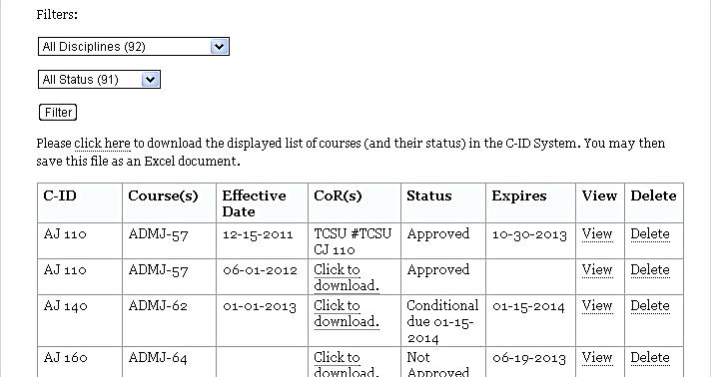
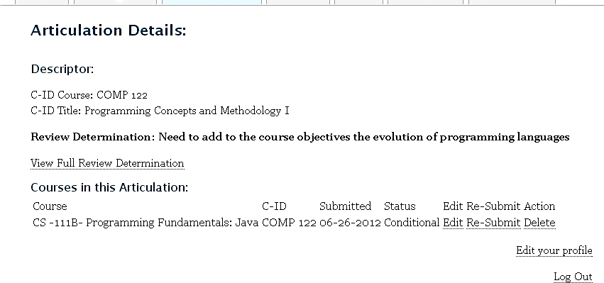

Resubmitting Courses Deemed Conditionally Approved or Not Approved - Step One
- Click on “View” next to the course you wish to resubmit from “Your submitted courses” screen (top slide)
- Click on “Re-Submit” (bottom slide)

Resubmitting Courses - Step Two
- Enter the Effective Date and COR Date (see page 5 regarding these dates).
- If you need to address textbook issues, enter textbook information in the “textbook comments” box.
- In order to attach a revised outline, click on the appropriate method (online or upload).
- Enter any relevant response to the review determination in the bottom comment box (e.g. the changes requested were completed).
- Click “Re-Submit” to return the course to the review process.
  - A course which requires resubmission a second time is still granted a one year period within which to revise the course.
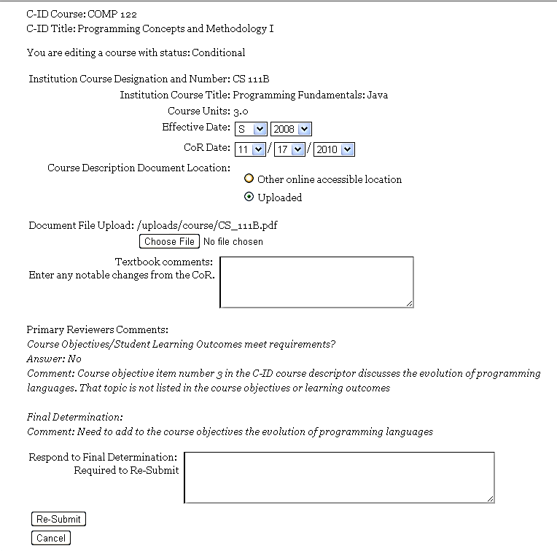

Textbook Only Resubmissions
- If you have a course conditionally approved due to a textbook issue ONLY prior to the change in textbook policy (7 years instead of 5 years), you may indicate that you now meet the new textbook age requirements in the comment box.
  - If you resubmit a course outline of record for a conditional approval which requested updated textbooks ONLY, you should NOT submit a new COR unless the only changes to the COR are the textbook changes requested. In other words, if you determine the textbooks being used are up to date, and you note your outline was updated in other areas since the original submission to C-ID, do not submit the new outline. Your best course of action is to delete the course in question and submit the new course outline for C-ID designation. If, however, you have a course outline of record which indicates only the changed textbooks, you may submit it. You can, however, simply enter the updated textbook information. If you are uncertain of how to proceed, please contact C-ID staff (aohotline@c-id.net).
- If your COR received a conditional approval due to the age of the textbooks under the new policy, this was the ONLY issue, and in practice you are using newer textbooks not reflected on the Course Outline of Record, you will enter textbook information in the comment box as indicated.
  - In these two textbook ONLY situations, you do not have to upload a new COR. Resubmission of a course without a COR is only allowed when a conditional approval is received which requires updates to the textbooks only and your college is using newer textbooks than are reflected on your COR. See next page.

Textbook Information Required

Required Textbook Information
    - Title
    - Author
    - Year

Appealing C-ID Determinations
C-ID COR Determination Appeal Process
Adopted as final at April 15, 2014 C-ID Advisory Committee Meeting

- If the Articulation Officer (AO) or a faculty member disagrees with a Conditional
or Not Approved review determination, then the AO contacts C-ID staff requesting an appeal.

  - C-ID staff requests the AO to provide detailed information about why he/she disagrees with the determination.

- Staff compiles an appeal package containing: (1) a copy of the course outline of record (COR) evaluation form with all comments (i.e., the comments of all three faculty reviewers), (2) a copy of the COR(s), (3) a copy of the descriptor in question and (4) the information provided by the AO. Staff reviews documents to ensure completeness prior to sending to the primary reviewer (PR).

- C-ID staff forwards the package to the PR to assess concerns and re-evaluate the COR in light of the new information.

- The PR provides further clarification and support regarding the appropriateness of the review determination to staff or indicates that the review should be returned to the initial reviewer(s) or the PR’s queue for action. If the PR’s revised determination is inconsistent with the determination made by either of the reviewers, the course will be returned to the reviewer(s) for reconsideration or those reviewers will be consulted prior to a change in the determination. In other words, if the revised determination would over-turn the determination made by either of the initial reviewers, he or she must agree to the new determination before it is made. If the original review determination is upheld after review by the PR or either of the reviewers, staff forwards the review outcome to the AO and indicates what modifications are required before a C-ID designation can be awarded.

Editing Institution Course Designation, Number, Title, Units and/or Effective Date
- Articulation Officers have the ability to edit certain information on a course previously submitted to C-ID.
  - The institution course designation and number can be changed (i.e. SPE 10 can be changed to COM 12).
  - The title of your course can be edited.
  - The number of units can be INCREASED only.
  - The effective date for the course can be changed.
- Locate the course needing a change.
- Click on “View”.
- Click on “Edit”.
- Make your changes and click on the “Edit” box.

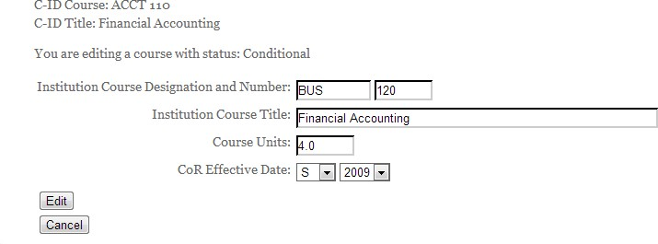

C-ID Approved Courses
- A list of approved courses for all colleges is available on the public side of the C-ID website at http://c-id.net/course_compare.html (see “Courses” tab on the website).
- C-ID designations will appear in ASSIST beginning spring 2013.
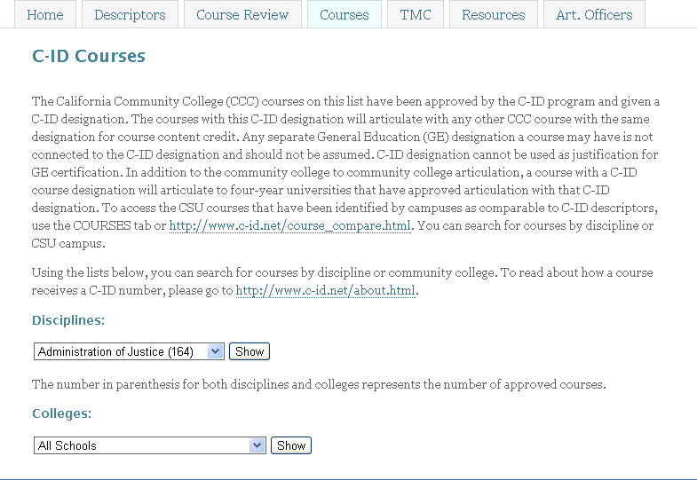

CSU Articulation and C-ID Descriptors
- Courses identified by CSU campuses as comparable to C-ID descriptors are found on the “Courses” tab of the C-ID website (http://c-id.net/course_compare.html). The CSU courses listed will articulate with approved CCC courses with the designation. However, comparable identification does not imply CSU-to-CSU articulation, nor does it imply reverse articulation of CSU-to-CCC courses.
  - Please note that you do not have to log in as an Articulation Officer. This area is accessible to the public.
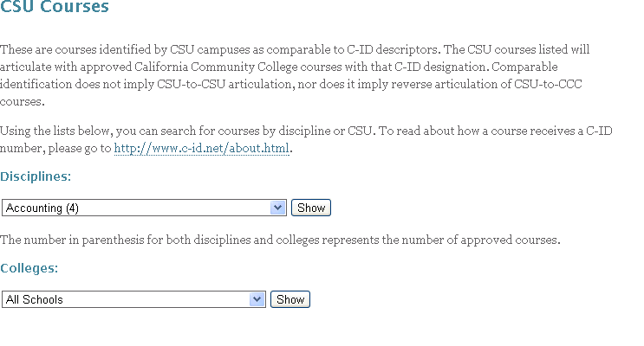

Approved Descriptor List
- A downloadable list of all approved C-ID descriptors is on the C-ID website (no log in required) under the “Descriptors” tab – “Final Descriptors” (http://c- id.net/view_final.html)
  - Articulation Officers may find it helpful to download a complete list of all approved C-ID descriptors into an Excel document. No password is needed to access this list as it is part of the public view for C-ID.
- From the Final Descriptors page, simply click on the “click here” link.
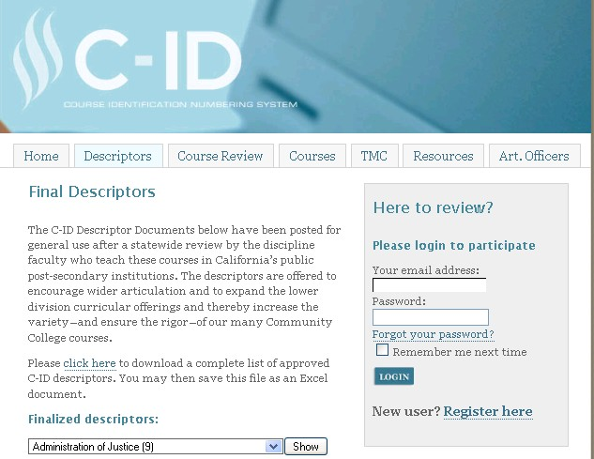
Download Approved Descriptors List

Tips:
- If a course outline becomes corrupted, or a link is no longer available, C-ID staff will contact you to obtain a replacement. Your course will not move through the C-ID review process until a copy of the course outline is provided.
- Articulation Officers have their own area on the C-ID website. Just click on the “Art. Officers” tab of the C-ID public website. Here you will find links to monthly updates and information. Anyone can sign up to receive the C-ID monthly updates by signing up for the C-ID Newsletter listserv (http://www.c-id.net/listserv.html).
- Administrators can access a list of their college’s C-ID submitted courses and the current review status with “admin_view” permission. This is a view only function with no submission or edit capability. Articulation Officers are the gatekeepers for the administrator view logon information and can distribute as they determine appropriate.

Technology Updates - Coming Soon:

- Course drop down and auto fill options will soon be available to assist Articulation Officers in entering information about their courses upon submission.
- A link will soon be available from your “Course Submission Area” page to view your college’s courses and their potential alignment with existing TMCs based on courses already submitted to C-ID.

Contact Information:

  - C-ID staff are available to assist you with any questions you may have.
o Email: c-idsupport@asccc.org
o Phone: (916) 445-4753

Thank you for submitting your courses for C-ID designations!
Recent Revisions

Date Change

4/19/13 Added Introduction (pg. 2)

Removed references to submitting courses via TCSU (throughout) Added Status chart re: CCCCO action (pg. 22)
Updated screenshots to reflect technology improvements (throughout) 12/16/14 Addition of language (in bold and parenthesis) to I.A. (p.7)
3/19/15 Included official “C-ID Appeal Process” language (p. 28)

